**Vernam Cipher**

Code :

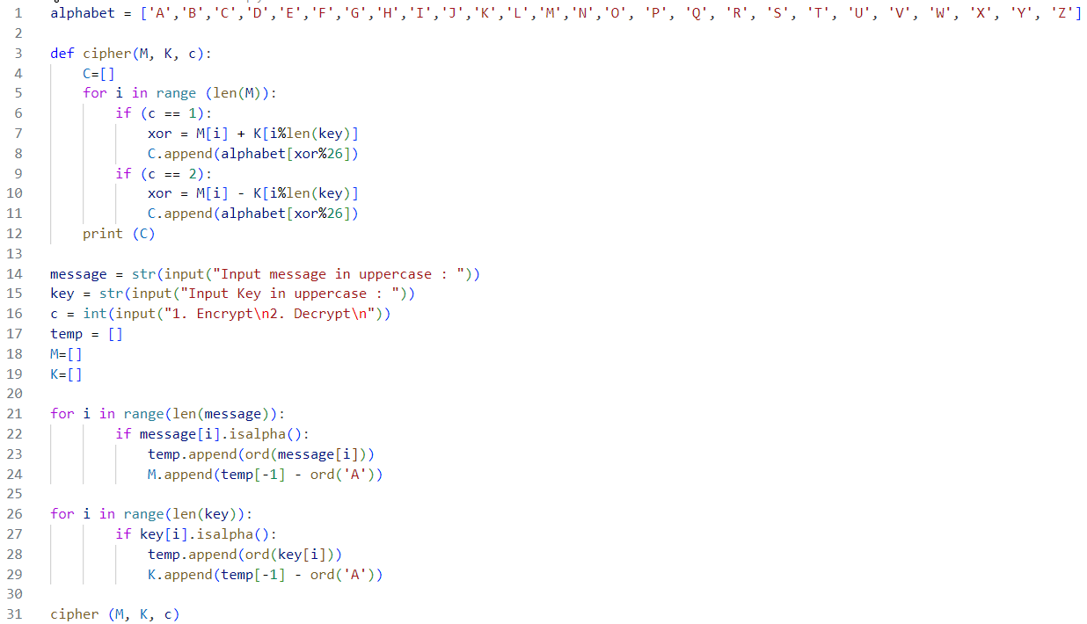

Output:

